IST 331: Human Centered Design

Northland Bowling High-Fidelity Prototype Modifications

Tristan Epler, Mark Ranieli, Brenden Kokiko, Mark Walsh

4/23/2023

**Select five recommendations from any of the above that are applicable to your project. Explain in detail how each is used and how it adds to the design.**

1. Enabling frequent shortcuts for users- In our design, we have a lot of clickables that lead to different types of information and making this information available in the least number of clicks and easiest way possible is imperative for a clean user experience.
2. Strive for consistency- Each page of our site has the same color background, the same 3 tabs for each of the business entities, and the same bottom bar. Something we could improve is the consistency of our fonts.
3. Permit easy reversal of actions- We are building a web site designed to be used in a browser, so the back button is integrated. We also have a persistent nav bar on our site, so the user can simply click back to where they want to be if they misclick.
4. User-Control and Freedom: in our design we always have multiple tabs on the top and throughout each page that are the same for every page and that help users remember how to move in between pages.
5. Error Prevention- Making sure each clickable is matched to the right information and making sure each clickable is mapped and easy to access to avoid users from not being able to find what they are looking and potentially misleading them to the wrong information

**Prototype Changes Completed (based on usability testing) and Rationales:**

Change 1: Fix the scrolling destination for the hours, pricing, and food buttons.

Rationale: This change is based on the WCAG guidelines for navigability, which state that users should be able to navigate to all content using the keyboard or other assistive devices. The correction ensures that the user can access the relevant information without difficulty, and it improves the overall user experience.

Change 2: Improve the visibility of the home button.

Rationale: This change is based on the visibility principle from Norman's design principles, which emphasizes the importance of making key features visible and discoverable. The improved visibility of the home button ensures that users are able to easily navigate back to the homepage from any page on the website.

Change 3: Adjust the front and background colors of the address and motel pages.

Rationale: This change is based on the WCAG guidelines for color contrast, which require that text and graphics have sufficient contrast with their background to be easily read and interpreted. By improving the contrast between the text and the background, the readability and accessibility of the pages are enhanced.

Change 4: Add a title to the Motel page.

Rationale: This change is based on the visibility principle from Norman's design principles, which emphasizes the importance of making key features visible and discoverable. By adding a title, the motel page becomes more visible and easier to use, improving the user experience.

Change 5: Remove unused social media icons.

Rationale: This change is based on the heuristic of simplicity from Nielsen and Molich's heuristics, which emphasizes the importance of reducing the complexity of the interface to improve usability. Removing unused social media icons simplifies the interface and reduces the visual clutter, improving the overall user experience.

Change 6: Adjust the text and image size on each page.

Rationale: This change is based on the visibility principle from Norman's design principles, which emphasizes the importance of making key features visible and discoverable. By adjusting the text and image size, the website becomes more visually balanced and easier to read, improving the user experience.

Change 7: Correct the grammar mistake on the birthday party's page.

Rationale: This change is based on the WCAG guidelines for readability, which require that the content of the website is easy to read and understand. By correcting the grammar mistakes, the website becomes more professional and improves the readability and accessibility of the content.

Change 8: Clarify that the user needs to call to set up a birthday party.

Rationale: This change is based on the visibility principle from Norman's design principles, which emphasizes the importance of making key features visible and discoverable. By clarifying that the user needs to call to set up a birthday party, the website becomes more user-friendly and reduces confusion, improving the overall user experience.

**Updated Prototype:**

<https://xd.adobe.com/view/09b50bba-0ff5-405e-9b9e-ad2a3d191540-5ce6/>

**Prototype Challenges While Designing:**

* Formatting everything and making sure all the changes were applied to every single page
* Figuring out what components to add and what components to take out.
* Resizing images and buttons
* Figuring out how to incorporate feedback into actual design changes.
* Figuring out what feedback we should use to make the new changes and figuring out which changes would be too hard to do, and which are well within our ability
* Creating a consensus as a team from our testing on which changes to make to the webpage.
* Just like with the original high-fidelity prototype, keeping in mind the design heuristics and gestalt principles and making sure we try to improve our website to make sure they match them even better.
* Figuring out how to establish a “home page” for the document and making the logo on the top right corner usable with home page functionality.

Before:

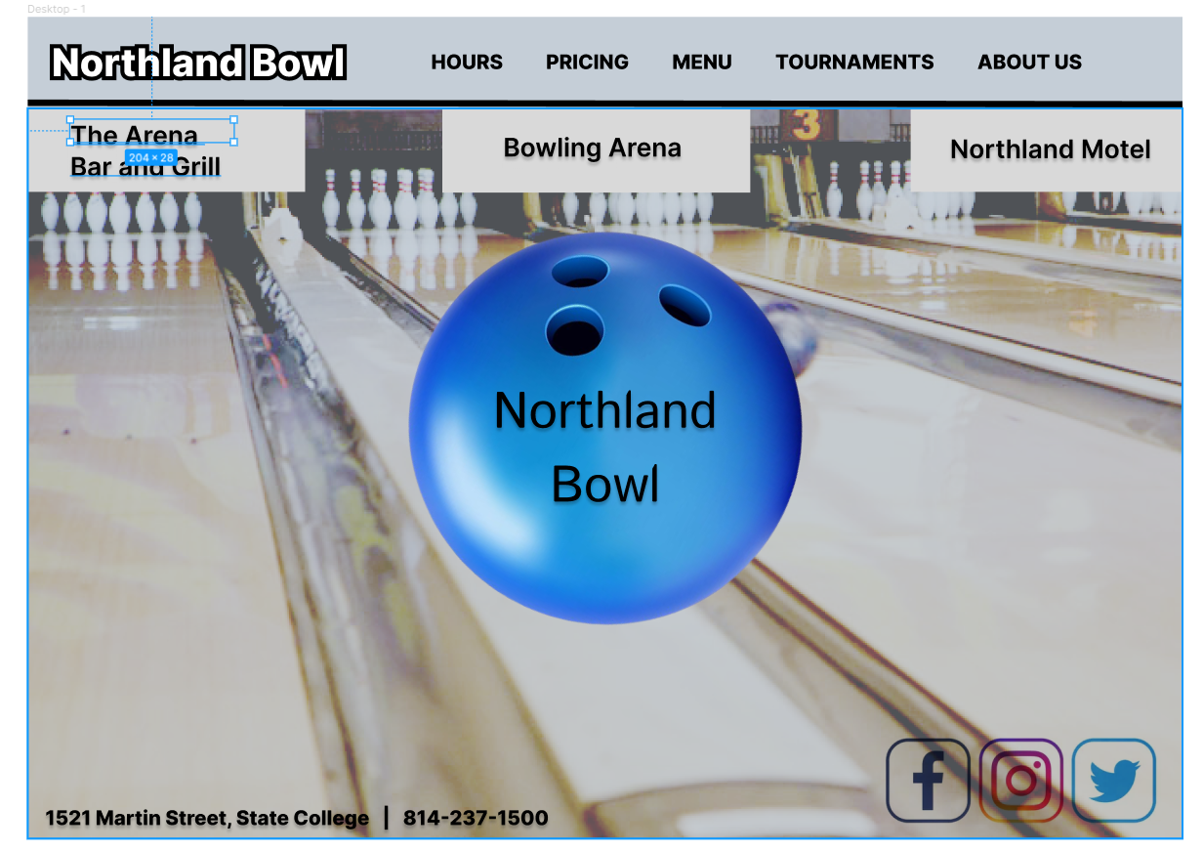

After:

